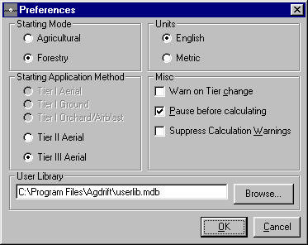

New frame: User Library
- User can type directly into text box the path name of an existing library or the desired path of a new library.
- Clicking on Browse button brings up a file browser.
- Clicking OK in the file browser fills the text box with the path of an existing library.
- Clicking Cancel in the file browser leaves the text box unchanged.
- The existance of the library file is not checked here, only the path is set. If a path to a nonexistant library is specified here, there will be an opportunity to create it when an attempt is made to add a new entry.
- The program will not ship with a user library file, but will have the path set initially as shown.
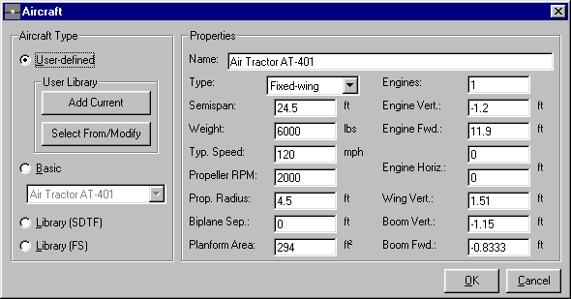

New frame: User Library
- The User Library Frame and controls are available only if:
- A user library path has been specified in Preferences
- The Aircraft Type is set to User-Defined
- Clicking Add Current adds the currently defined aircraft to the user library and brings up the Aircraft User Library form.
- If the User Library exists and no entry of the same name is present, the new entry is added to the library, and the Aircraft User Library form is shown with the new entry selected.
- If the User Library exists, but an entry with the same name is already present, a dialog appears: “An entry with this name already exists. Replace? Ok/Cancel”
- Clicking Ok overwrites the existing entry and operation continues as above.
- Clicking Cancel aborts the Add Current operation.
- If the user library does not exist, a dialog pops up: “The user library library path does not exist. Create it now? Yes/No.”
- Clicking Yes will create a new blank user library and add the new entry to it.
- Clicking No aborts the Add Current operation. No user library is created, and the User Library form is not shown.
- Clicking Select From/Modify shows the Aircraft User Library form.
- If an entry of the same name is present, that entry is selected when the form appears.
- If an entry of the same name is not present, the first library entry is selected.
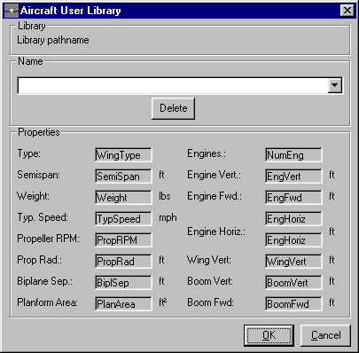

New form: Aircraft User Library:
- Library frame: displays the current user library path.
- Name frame: Combo box is populated with all names present in the library in alphabetical order.
- Delete button deletes the currently selected entry from the library. A confirmation dialog is presented first which reads “Delete current selection? OK/Cancel”
- Properties frame: labels here display aircraft data for the current entry. They are updated whenever the Name combo is manipulated.
- OK button: transfers the currently selected aircraft entry to the parent Aircraft form and dismisses this form.
- Cancel button: Dismisses this form without transferring data.
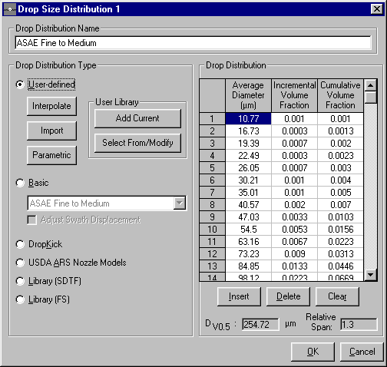

New frame: User Library
- Behavior of these controls parallels that of the Aircraft User Library controls.
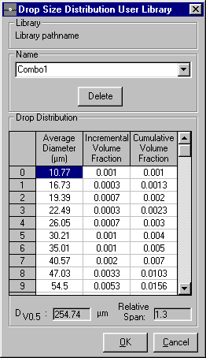

New form: Drop Size Distribution User Library.
- Behaves like Aircraft User Library

